# **B****usiness Process Model**

*Package in package 'Model'*

Business Process Model

Version Phase 1.0 Proposed

sj981 created on 31/12/2020. Last modified 31/12/2020

## **Business Process Model diagram**

*Analysis diagram in package 'Business Process Model'*

Business Process Model

Version 1.0

sj981 created on 31/12/2020. Last modified 31/12/2020

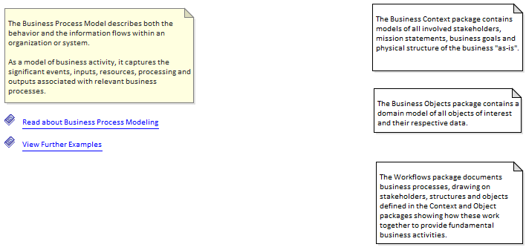

Business Process Model

## **Note**

*Note in package 'Business Process Model'*

The Business Context package contains models of all involved stakeholders, mission statements, business goals and physical structure of the business "as-is".

Note

Version 1.0 Phase 1.0 Proposed

sj981 created on 31/12/2020. Last modified 31/12/2020

Extends

## **Note**

*Note in package 'Business Process Model'*

The Business Objects package contains a domain model of all objects of interest and their respective data.

Note

Version 1.0 Phase 1.0 Proposed

sj981 created on 31/12/2020. Last modified 31/12/2020

Extends

## **Note**

*Note in package 'Business Process Model'*

The Workflows package documents business processes, drawing on stakeholders, structures and objects defined in the Context and Object packages showing how these work together to provide fundamental business activities.

Note

Version 1.0 Phase 1.0 Proposed

sj981 created on 31/12/2020. Last modified 31/12/2020

Extends

## **Note**

*Note in package 'Business Process Model'*

The Business Process Model describes both the behavior and the information flows within an organization or system.

As a model of business activity, it captures the significant events, inputs, resources, processing and outputs associated with relevant business processes.

Note

Version 1.0 Phase 1.0 Proposed

sj981 created on 31/12/2020. Last modified 31/12/2020

Extends

## **$help://analysisdiagram.htm**

*Text in package 'Business Process Model'*

$help://analysisdiagram.htm

Version 1.0 Phase 1.0 Proposed

sj981 created on 31/12/2020. Last modified 31/12/2020

Alias View Further Examples

Extends

## **$help://business_process_model_pattern.htm**

*Text in package 'Business Process Model'*

$help://business_process_model_pattern.htm

Version 1.0 Phase 1.0 Proposed

sj981 created on 31/12/2020. Last modified 31/12/2020

Alias Read about Business Process Modeling

Extends

## **S****istema**

*Package in package 'Business Process Model'*

Sistema

Version 1.0 Phase 1.0 Proposed

sj981 created on 31/12/2020. Last modified 31/12/2020

### **Sistema diagram**

*Business Interaction diagram in package 'Sistema'*

Sistema

Version 1.0

sj981 created on 31/12/2020. Last modified 18/01/2021

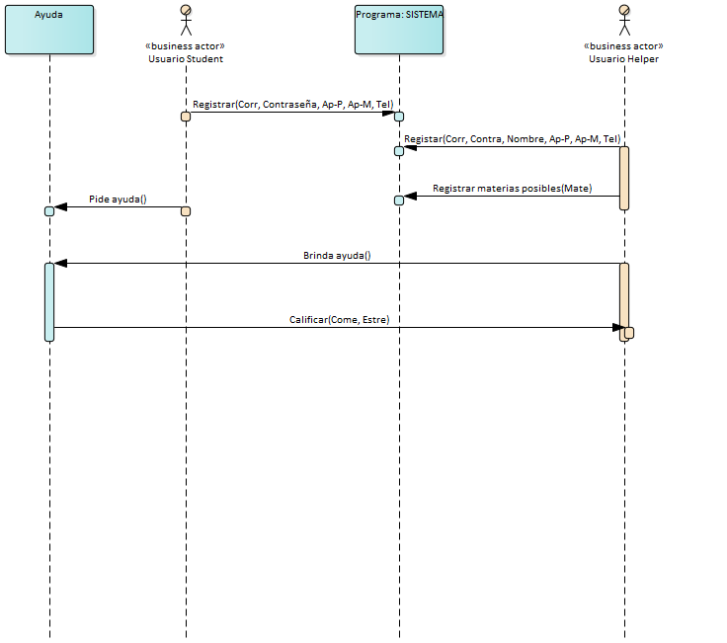

Sistema

|  |
| --- |
| **INTERACTION MESSAGES** |
| **1.0 'Registrar'** from 'Usuario Student' sent to 'Programa: SISTEMA'.  Synchronous Call. Returns void.  [ Return is False. Iteration is False. New group is False. ] |

|  |
| --- |
| **1.1 'Registar'** from 'Usuario Helper' sent to 'Programa: SISTEMA'.  Synchronous Call. Returns void.  [ Return is False. Iteration is False. New group is False. ] |

|  |
| --- |
| **1.2 'Registrar materias posibles'** from 'Usuario Helper' sent to 'Programa: SISTEMA'.  Synchronous Call. Returns void.  [ Return is False. Iteration is False. New group is False. ] |

|  |
| --- |
| **1.3 'Pide ayuda'** from 'Usuario Student' sent to 'Ayuda'.  Synchronous Call. Returns void.  [ Return is False. Iteration is False. New group is False. ] |

|  |
| --- |
| **1.4 'Brinda ayuda'** from 'Usuario Helper' sent to 'Ayuda'.  Synchronous Call. Returns void.  [ Return is False. Iteration is False. New group is False. ] |

|  |
| --- |
| **1.5 'Calificar'** from 'Ayuda' sent to 'Usuario Helper'.  Synchronous Call. Returns void.  [ Return is False. Iteration is False. New group is False. ] |

### **Usuario Helper**

*Actor «business actor» in package 'Sistema'*

Usuario Helper

Version 1.0 Phase 1.0 Proposed

sj981 created on 31/12/2020. Last modified 31/12/2020

| **OUTGOING BEHAVIORAL RELATIONSHIPS** |
| --- |
| Name: Registrar materias posibles  Sequence from «business actor» Usuario Helper to Programa: SISTEMA |

|  |
| --- |
| Name: Registar  Sequence from «business actor» Usuario Helper to Programa: SISTEMA |

|  |
| --- |
| Name: Brinda ayuda  Sequence from «business actor» Usuario Helper to Ayuda |

| **INCOMING BEHAVIORAL RELATIONSHIPS** |
| --- |
| Name: Calificar  Sequence from Ayuda to «business actor» Usuario Helper |

### **Usuario Student**

*Actor «business actor» in package 'Sistema'*

Usuario Student

Version 1.0 Phase 1.0 Proposed

sj981 created on 31/12/2020. Last modified 31/12/2020

| **OUTGOING BEHAVIORAL RELATIONSHIPS** |
| --- |
| Name: Registrar  Sequence from «business actor» Usuario Student to Programa: SISTEMA |

|  |
| --- |
| Name: Pide ayuda  Sequence from «business actor» Usuario Student to Ayuda |

### **Ayuda**

*Sequence in package 'Sistema'*

Ayuda

Version 1.0 Phase 1.0 Proposed

sj981 created on 11/01/2021. Last modified 11/01/2021

| **OUTGOING BEHAVIORAL RELATIONSHIPS** |
| --- |
| Name: Calificar  Sequence from Ayuda to «business actor» Usuario Helper |

| **INCOMING BEHAVIORAL RELATIONSHIPS** |
| --- |
| Name: Brinda ayuda  Sequence from «business actor» Usuario Helper to Ayuda |

|  |
| --- |
| Name: Pide ayuda  Sequence from «business actor» Usuario Student to Ayuda |

### **Object1**

*Sequence in package 'Sistema'*

Object1

Version 1.0 Phase 1.0 Proposed

sj981 created on 11/01/2021. Last modified 11/01/2021

### **Programa: SISTEMA**

*Sequence in package 'Sistema'*

Programa: SISTEMA

Version 1.0 Phase 1.0 Proposed

sj981 created on 11/01/2021. Last modified 11/01/2021

| **INCOMING BEHAVIORAL RELATIONSHIPS** |
| --- |
| Name: Registrar materias posibles  Sequence from «business actor» Usuario Helper to Programa: SISTEMA |

|  |
| --- |
| Name: Registrar  Sequence from «business actor» Usuario Student to Programa: SISTEMA |

|  |
| --- |
| Name: Registar  Sequence from «business actor» Usuario Helper to Programa: SISTEMA |